**Debugging & Traceability**

What factors affect the resale value of a car?

**Here are a few factors that go into determining used car trade-in value.**

* The Age of Your Trade-In. ...
* The Mileage on Your Trade-In. ...
* The Overall Condition of Your Trade-In. ...
* The History of Your Car's Maintenance. ...
* The Equipment in Your Car. ...
* Current Demand Dictates the Deal.
* Make a Good Impression at Trade-In Time.
* Will car values drop in 2022?
* Average prices were up 42.5% in September 2022 vs. February 2020. Used car prices have likely peaked, but **new car prices are set to remain elevated through end-2022**. In 2023, prices are expected to decline by 2.5% to 5% for new cars and by 10% to 20% for used cars.

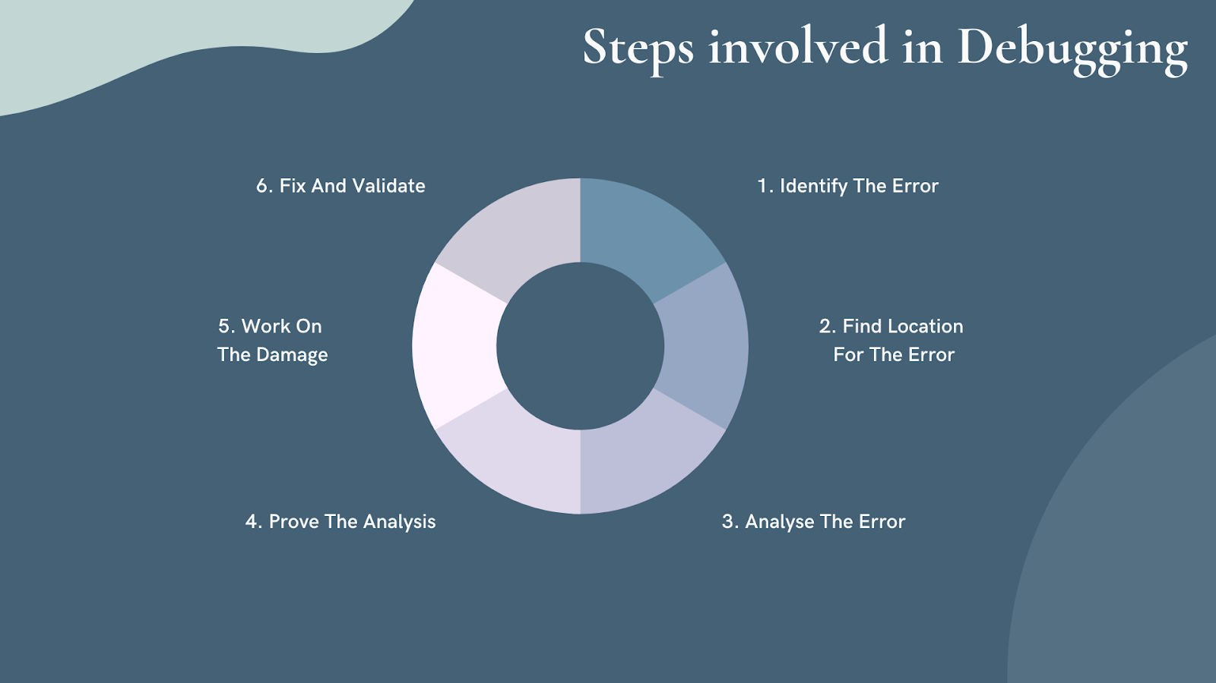

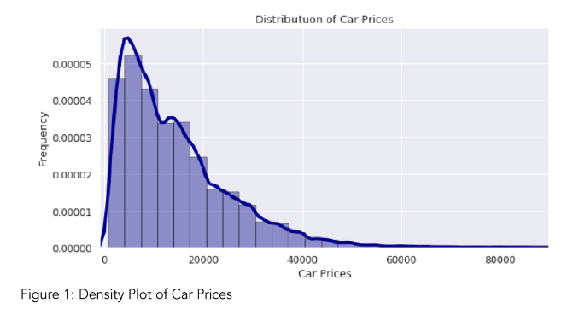

What is the most important factor in determining a car’s resale or trade-in value?

Many factors figure into the value of a used car, but **mileage and condition** are the most important. After that, options, location, and color are influencing factors.

What are 4 factors to consider when buying a car?

**The Top 5 Factors to Consider When Purchasing a New Car**

* Price. Arguably the most important factor to consider when purchasing a car is the cost of the vehicle. ...
* Features. ...
* Resale Value. ...
* Maintenance. ...
* Protect Your Car with Endurance.